Area 8 Pathfinder Coordinators: Susan Preston, Kim Roberts-Waldron, Tyronne Waldron

AREA 8 CURRICULUM CAMP

03rd May – 06th May, 2019

This document is a guide, which, if followed, will have you and your club ready for our Area Curriculum Camporee. This document includes the application forms, medical forms, church board approval forms and camp equipment check lists.
Table of Contents
The Venue/Campsite 2
Address 2
Getting to the Venue/Campsite 3
Road Map 3
Phone boot Marker 4
Site Map 5
Camp Registration 6
Admin Folder Inspection 6
Child Protection 6
Medical Care 6
Dress Code 7
Scarf 7
Dress Uniform 7
Field Uniform 7
Camp Itinerary & Programming 8
Camp Staff 9
Other Information 9
Friends 9
Companions 9
Explorers 9
Rangers 9
Voyagers 10
Guides 10
Ordnance Survey Maps 10
Stationary Items / Chairs / Rucksacks 10
Activities 11
Camp Gear – Individual 11
Camp Gear – Club 12
Church Board Acknowledgement 13
Emergency Contact Information 14
Admin Folder Inspection Form 15
Campsite Inspection Form 16
Club Application Form 17
Pathfinder/Staff Application Form 18
Medical Form 19
Fair Programme 21
Adventurers 21
Pathfinders 21
Masterchef 22
Knot tying relay 22
First Aid Relay 23
Fitness relay – Two participants male and female 24
Campsite Layout 25

The Venue/Campsite

Address

https:// http://www.bradfieldparkcampsite.org.uk
The address of Bradfield Park Scouts is:
Ixer Lane
Bradfield Combust
Bury St. Edmunds
IP30 0LR

Getting to the Venue/Campsite

Road Map
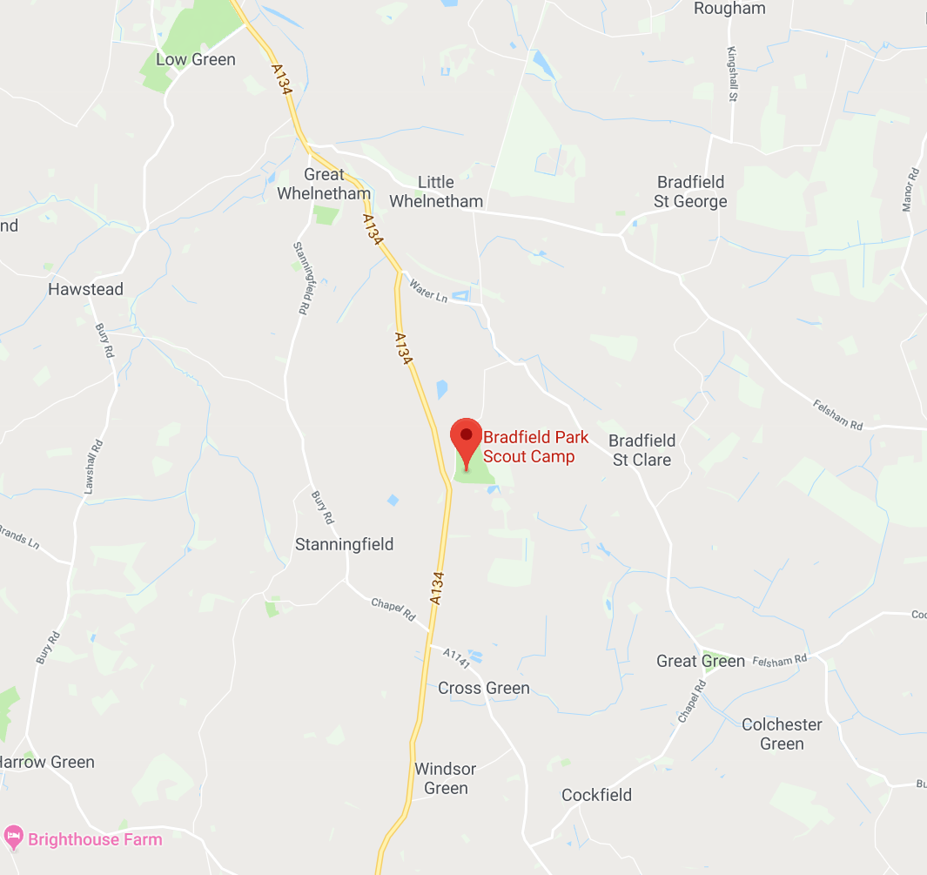

Phone boot Marker
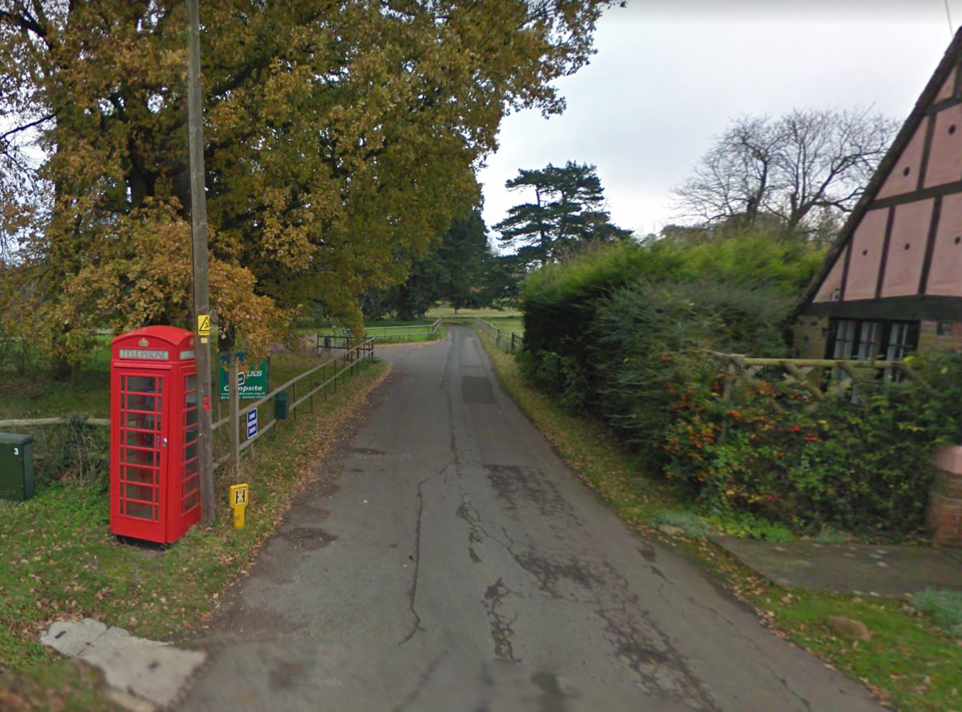

Site Map
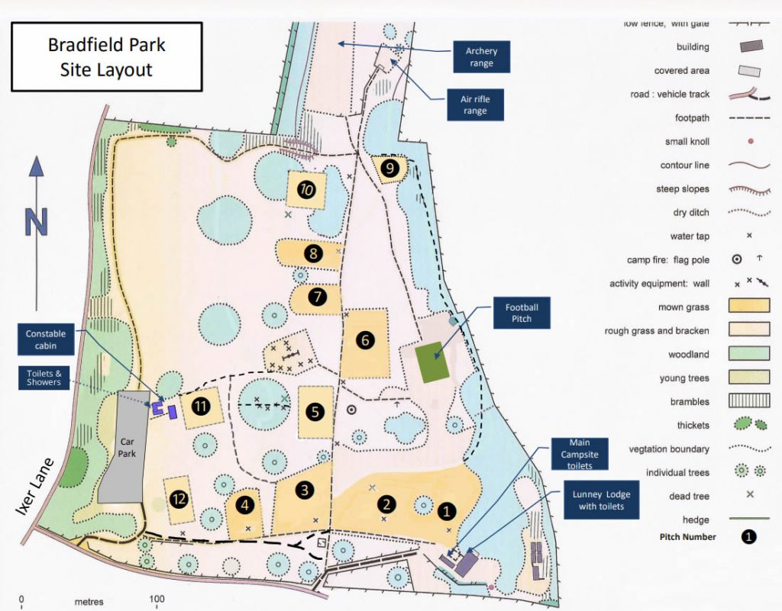

Camp Registration
On arrival, club directors are to register every member of their group at the Registration Desk

Admin Folder Inspection
As part of the registration process, folders will be collected on arrival and returned to clubs after they have been inspected. Clubs are asked to ensure that their folder is organised in the same sections and order as the Administration Folder Inspection form.

Child Protection
The local Church Board is responsible for ensuring that leaders, counselors and instructors attending the camp meet the requirements of the British Union Child Protection Policy: Keeping Our Church Family Safe.
All adults over the age of 16 require a current DBS check (undertaken by the SEC within the past 3 years). Please ensure that all club leaders see the checks prior to the camp. If there are any concerns about the DBS check please inform the Area Coordinator.
If a safeguarding matter arises at any point during the camp, please inform the designated Safeguarding Lead immediately who will follow the SEC safeguarding protocol.

Medical Care
Each club is responsible for providing medical care for their own group.
At least one member of the Club First Aid Team should be qualified to a minimum level of Basic First Aid. The team must also ensure that they have an appropriate first aid kit for the size of the group and the nature of the activities.
A completed Medical Information form for each member of the group must be obtained and kept as part of the club Administration Folder.
Clubs may carry, at their own discretion, various over the counter (OTC) drugs, which can then be administered on the advice of those providing first aid.
Over the counter drugs should be stored separately from the first aid kit and may include:
- Sun creams or sprays, at least factor 15
- Lotions for after sunburn treatment
- Insect bite cream
- Pain Killers - Paracetamol, Co-codamol 8/500
- Anti-inflammatory drugs - Ibuprofen (also known as neurofen)
- Anti-diarrhoea - Loperamide
- Constipation - Plenty of Fruit and Vegetables, if this fails, lactulose
- Antihistamines (for insect bites)

A completed Medical Information form for each member of the group must be obtained and kept as part of the club Administration Folder
- Chlorpheniramine (Piriton) Sedating
- Cetirizine Non-sedating
- Anthisan cream

Any other drugs, such as antibiotics, will have to be provided via the local GP or Accident and Emergency facility.
Group members who need medication (e.g. for diabetes, asthma or hay fever) should bring a double supply of their medication and a spare prescription to take to the chemist. Please ensure that a care plan is attached to the medical form for children with specific health needs ( i.e. asthma inhalers, epipen etc.)
The Club First Aid Team should keep each group member’s medication in a separate bag clearly marked with the individuals name and monitor the distribution carefully. These should be stored in a safe and secure place.

Dress Code
Please pay close attention to the information to follow in this section as our dress code should be adhered to very strictly. In general, modesty is to be expected of all our campers: male, female, pathfinder and staff.

Scarf
The Pathfinder Scarf or Master Guide Scarf MUST be worn at ALL times throughout this camp. The scarf is a part of field uniform and the dress uniform. There will be no excuse for not wearing your scarf while at camp.

Your scarf MUST be worn at ALL times throughout this camp.

Dress Uniform
The dress uniform is NOT needed for this camp.

Field Uniform
A field uniform (Church, Area or SEC field uniform) should be worn at all times throughout the camp. REMEMBER, the scarf is part of the field uniform.
The SEC Field Uniform is made up of your scarf and woggle, grey tops with black jogging bottoms

Camp Itinerary & Programming
Sent out Seperately
LIGHTS OUT AT 2300hrs!

Camp Staff
There will be a small team of camp staff who will be responsible for ensuring that the camp runs smoothly.
There will be no other staff apart from your club staff. It means that each club MUST ensure that they have adequate staff to cover the number of pathfinders they bring.

Other Information
Each club will need to bring or prepare the following items which your Pathfinders will use to fulfil the various honours and course requirements. Please note that these items are per participant NOT per club.

Friends
Ropes for knots
Small back pack for the hike
Utensils to cook their own food
Bring seeds from a variety of fruits and vegetables.
Learn the track and trail signs- test done at camp.
Learn 10 safety rules test will be done at camp.
Review the notes on general safety. Test at camp

Companions
Ropes for knots
Small back pack for nature walk
Utensils to cook their own food
Start creation 7 day log on Sunday 28th April. Everyday observation and log to be done until sabbath at camp. Logs will be reviewed at camp.
12 native trees and 12 birds - review the sheets. https://www.woodlandtrust.org.uk/visiting-woods/trees-woods-and-wildlife/british-trees/a-z-of-uk-native-trees/
http://fatbirder.com/links_geo/europe/england_suffolk.html
https://www.birdguides.com/sites/europe/britain-ireland/britain/england/suffolk/
Safety rules for fire lighting to be learnt as well as the different types of fires. Test at camp.

Explorers
Topographical map (any)
Utensils to cook their own food
Create meal plans
Review types of dehydrated foods
Research what Topographic maps are.
Review Basic Rescue requirements
Review the basic lashings sheet, understand what they are used for.

Rangers
Cardbord box
Kitchen foil (loads)
Back pack – 1 per club would do
Ingredients to mix and bake a cake
Utensils to cook their own food
Review how to pack a rucksack
https://www.thebmc.co.uk/how-to-pack-a-rucksack

Review chart of wild plants found in Uk
https://www.woodlandtrust.org.uk/visiting-woods/things-to-do/foraging/
http://www.bbc.co.uk/handsonnature/woodlands/bradfield_access.shtml
SWT have over fifty reserves, and while not all of them are suitable for foragers, sites like Knettishall Heath, Bradfield Woods, Lound Lakes and Foxburrow Farm are full of treasures to pick, snip, and harvest. The Trust often runs foraging courses and you can check the events page of their website, www.suffolkwildlifetrust.org, to find out when and where they’re taking place
Review fire safety and how to tighten and use and replace axe handle.
Prepare and bring in and outline of your exercise programme.

Voyagers
OS Map 211 – Bury St Edmund
Gloves -for pioneering
Rope – for pioneering
Small backpack to carry food for day expeditions
Utensils to cook their own food
Review the camp cooker honour before coming to camp.
Review the story of Nicodemus as in manual. Review the life cycle of a butterfly. Discussion at camp.
Walk with questions & your views on the story.
Research activities that can be done on a sabbath afternoon. Review the principles of Christian recreation.
Review lashings and review the page in the manual that shows different types of camp furniture.
https://www.scoutactivitycentres.org.uk/wp-content/uploads/2014/01/factsheetLashings.pdf
https://www.bing.com/videos/search?q=how+to+do+lashings&docid=608026694788452247&mid=3078AECF7729317974C33078AECF7729317974C3&view=detail&FORM=VIREHT

Guides
OS Map 211 – Bury St Edmund
Gloves – for Pioneering
Ropes for Pioneering
Own stove, tent, sleeping gear.
Rucksack for overnight hike
Utensils to cook their own food
Prepare 10 min presentation on making and keeping friends. This is for Friday vespers.
Plan three course meal plan
Research what are the gifts of the spirit
Familiarise yourself with requirements for sanctuary, ecology, nutrition and basic rescue honours.
Read Temperance pgs 102 – 125 – discussion and quiz will be done at camp
Review lashings
Read chapter 7 of desire of ages, this will be discussed at camp and relate it to nature.

Ordnance Survey Maps
Map details:
Ordnance Survey ‐Maps: (OPTIONAL)
OS Map 211 – Bury St Edmund

Stationary Items / Chairs / Rucksacks
As this is a Curriculum Camporee, all pathfinders MUST have a notebook (writing paper to place into their folder), pens, pencils, colouring pencils, rubber, sharpener and a clip board where possible.
Everyone will be required to bring a camping chair as there will be no chairs available for us to use
It is recommended that ALL pathfinders use Rucksacks rather than suitcases or any other luggage

Activities

Camp Gear – Individual
Bible
Pathfinder Folder
Club Field Uniform (including Scarf)
Sleeping bag
Sleeping mat
Underwear
Spare top layers as necessary
Fleece
Waterproof coat & trousers
Toiletries
Torch
Woolly hat
Cap
Personal Medication (if required)
Dining sets (plate, cup, and spoons)
Compass
Camp Chair/stool

Camp Gear – Club
Kitchen Tent
Kitchen preparation tables
Stove burner
Gas & regulator
Kitchen Lamp
Pot, pans & serving implements
Food storage boxes
Food containers
Water containers
Drink containers
Cleaning supplies: mop & bucket, dust-pan & brush, broom etc
Washing-up bowls & liquid
Fire blanket, fire buckets
Cool box
Dining Tent
Tables & benches (could be useful….)
Sleeping tents (See list under tent layout)
Sleeping Mats
Extra groundsheets
Tool box (lockable - use an export barrel)
Flat head & cross head screwdriver
Wooden mallet
Hammer
Extra gas hose & jubilee clips
Sisal & polypropylene rope
Knife
Bow saw
Boundary tape
Wet-pit stakes & bin liners
Garden gloves & safety glasses
Safety Goggles
Measuring tape/rope
Disposable gloves

Church Board Acknowledgement
SEC Area 8 Pathfinder Curriculum Camp
Bradfield Combust Bury St. Edmunds IP30 0LR  03rd May – 06th May, 2019  Bradfield Parck Scout Campsite Ixer Lane |  | Area 8
Pathfinder Clubs
Group Leader Details

Title: Mr/Mrs/Ms/Miss/Other …………………………………………………………..………………
Surname ………………………………… First Name ...………………………….………………
Address .....................................................................................................................................
……………………………………..……... Post Code ….…………………………………………..
House Telephone……………..….….…. Mobile .……………………………………….…………
Email Address ………………………………………………………………………………………….

Group Details

Total Number of Pathfinders ………………………….

Total Number of Club Staff ………………………….

Church Board Approval

We, the members of the

………………………………………………………………………………………………………..

Church Board, confirm that the group leader is a suitably responsible person to lead our Pathfinder club to the Pathfinder Curriculum Camp and that we are satisfied with the Risk Assessment they have presented to us.

We confirm that all members of staff meet the requirements of the British Union Child Protection Policy: Keeping our Church Family Safe and that each person has Club Insurance cover.

We understand that the cost of this Pathfinder Curriculum Camp is £15 per person. All payments are to be made in full by 28th April 2019

Signed …………………………………………………………… Date ………………………………
(Church Clerk on behalf of Church Board)

Emergency Contact Information
SEC Area 8 Pathfinder Curriculum Camp
Bradfield Combust Bury St. Edmunds IP30 0LR  03rd May – 06th May, 2019  Bradfield Parck Scout Campsite Ixer Lane |  | Area 8
Pathfinder Clubs
Name of Club ________________________________________________________

Child’s Name | Emergency Contact Name | Emergency Contact Number

Admin Folder Inspection Form
SEC Area 8 Pathfinder Curriculum Camp
Bradfield Combust Bury St. Edmunds IP30 0LR  03rd May – 06th May, 2019  Bradfield Parck Scout Campsite Ixer Lane |  | Area 8
Pathfinder Clubs

Name of Club ________________________________________________________

One Point Per Item
Section One – Club Information |  | Section Three – First Aid
Copy of Church Board Registration Form |  | One First Aid at Work Certificate
Individual Application Forms |  | Section Four – Risk Assessment
Individual Medical Forms |  | Travel Plan from start to Campsite
2 copies of Named List with Emergency Contact Details |  | Tent Allocations
 |  | Counsellor allocations
Section Two – Cooks Information |  | Club Code of Conduct
Head Cook Health & Hygiene Certificate/ or In-house Food Awareness Certificate |  | Emergency Plan to take someone to hospital
Individual Meal Plan |  | Emergency Plan to take someone home
Cooking & Washing Up Rota |  | Travel Plan from Campsite to finish point
 | Total Points
Club Director's Signature:
Inspector's name:
Please print:

Campsite Inspection Form
SEC Area 8 Pathfinder Curriculum Camp
Bradfield Combust Bury St. Edmunds IP30 0LR  03rd May – 06th May, 2019  Bradfield Parck Scout Campsite Ixer Lane |  | Area 8
Pathfinder Clubs
Name of Club ________________________________________________________
One Point Per Item
Campsite Layout |  |  | Cook Tent
All tents 3m away from adjoining pitch boundary |  |  | Gas Bottles safe & secure
All sleeping tents 3m apart |  |  | All food stored in sealed containers
Cook tents and altar fires 6m apart |  |  | All prep areas clean
No rubbish on pitch |  |  | Fire blanket or bucket of water/sand
Dining Shelter |  |  | Cleaning fluids safely stored
Clean & Tidy |  |  | Wet-pit area clean & tidy
Sleeping Tents |  |  | Kitchen Staff Inspection
Guy ropes taut and in line with flysheet seams |  |  | Cooks hat or hairnet
Guy ropes in line with tent poles |  |  | Cooks Apron
Nothing touching the tent inner walls
Inside clean & tidy |  |  | First Aid
Structures & Equipment |  |  | First Aid kit appropriate for the size of the group
All structures safe & secure |  |  | Individual medical bags as required
All tools & equipment safely stored |  |  | Individual medication/Dispensing Checklist
 |  | Total Points
Club Director Signature:
Inspectors name:
Please print:

Club Application Form
SEC Area 8 Pathfinder Curriculum Camp
Bradfield Combust Bury St. Edmunds IP30 0LR  03rd May – 06th May, 2019  Bradfield Parck Scout Campsite Ixer Lane |  | Area 8
Pathfinder Clubs
Cost: £15 per Person

Club name: ____________________________________________
Club Leader: ____________________________________________
Contact Number: ____________________________________________
Email: ____________________________________________

Class | No. Of Males | No. Of Females
Friends
Companion
Explorer
Ranger
Voyager
Guides
Adults
Total Attendees

Total Number of Attendees
Total amount paid
*Payment Reference
Area 8 Bank details:
Name on Account: The Seventh-Day Adventist Church – Area 8;
Sort Code: 40-18-04
Account Number: 42363976
*Payment reference should be PFCC19 + The first three letters of your church.
e.g. The reference for a payment from Basildon for this year’s curriculum camp should look like this PFCC19BAS.
The reference for a similar payment from Ipswich will look like this PFCC19IPS.
Please try to limit payments to a single transaction

Pathfinder/Staff Application Form
SEC Area 8 Pathfinder Curriculum Camp
Bradfield Combust Bury St. Edmunds IP30 0LR  03rd May – 06th May, 2019  Bradfield Parck Scout Campsite Ixer Lane |  | Area 8
Pathfinder Clubs
Cost: £15 per Person

Club Name_____________________ Pathfinder Class_____________________
Attach Photo here
Camper’s Details
Campers Name ___________________________________________ Birth Date ___/___/_____
Age ___ Parent’s/Guardian’s Name(s) ______________________________________________
Address _______________________________________________________________________
City ______________________County______________________ Postcode________________
Home Phone _______________________ Emergency Phone ___________________________

Photography Consent
Current regulations relating to The Data Protection Act 1998 requires that we obtain your consent for images taken of your son/daughter (under 18 years) which are used in either video or still shots. Only first names might be used and/or the name of the club to which they are a member. For further information on our Photographic Policy, please contact the SEC Office. As images will be recorded at all events you may wish to consider this in your application if consent is not given.

Please read the photography consent section above and tick yes if you give consent. YES, NO

Child Protection - Staff
Criminal Records Bureau Certificate Number: __________________________________________
Child protection training: have you done the KCFS training? YES, NO
Every person over the age of 16years must have a DBS certificate,

I hereby give permission for my child to attend this event and to take part in the activities arranged. I agree to notify the leaders should there be any change to the information given.

Signed: ______________________________________ Date: ___/___/_____

Area 8 Pathfinder Coordinator  Tyronne Waldron  +44 795 606 7485  Tyronne.waldron@area8pathfinders.org.uk | Area 8 Pathfinder Coordinator  Kim Roberts-Waldron  +44 7904 197510  Kim.roberts-waldron@area8pathfinders.org.uk | Area 8 Pathfinder Coordinator  Susan Preston  +44 79436 08429  Susan.preston@area8pathfinders.org.uk

Medical Form
Medical Form
Bradfield Combust Bury St. Edmunds IP30 0LR  03rd May – 06th May, 2019  Bradfield Parck Scout Campsite Ixer Lane |  | Area 8
Pathfinder Clubs
CLUB NAME__________________________ AREA ____ Emergency Phone _______________________
Campers Name ___________________________________________ Birth Date ___/___/_____ Age ____
Parent’s/Guardian’s Name(s) ______________________________________________________________
Address ________________________________________________ City ____________________________
County____________________ Postcode ____________ Home Phone ____________________________

Medical Details:
☑=YES ☒=NO
Have you had: |  | Do you wear: | Please give the date of the last tetanus injection __/__/__.  If you are currently taking medicine please give the name of the drug and dosage details  _________________________  Do you have any food allergies?________________
Rheumatic fever:  |  | Glasses: 
Asthma:  |  | Contact lenses:
Fainting spells:  |  | Dentures: 
Diabetes: 
Kidney Disease:  |  | Are you allergic to:
Heart trouble:  |  | Penicillin: 
Menstrual problems: |  | Anaesthetic: 
Hernias: 
Travel sickness:  |  | Tetanus injection in last 5 years? 

Name of GP/Doctor _____________________________________Surgery____________________________________
Address ___________________________________________ City ____________________County________________
Postcode ____________ GP/Doctor Phone _________________________ NHS Number ______________________

Behavioral Challenges
Are there any behavioural challenges that the organisers should be aware of? Yes / No
If yes, please specify

__________________________________________________________________________________________________________________________________________________________________________________________________________________________________________________________________________________

Disability
Are there any disabilities / additional needs that the organisers should be aware of? Yes/ No
If yes, please specify

__________________________________________________________________________________________________________________________________________________________________________________________________

Other Information
If there is anything else that should be considered by the club, relating to the health and/or ability of the above mentioned person, please state clearly below: __________________________________________________________________________________________________________________________________________________________________________________________________

Authorisation
This health report is correct as far as I know, and the person described has permission to engage in all prescribed activities, except as noted by me. In the event of an emergency, I hereby give permission to the physician selected by the adult leader in charge to hospitalise or treat including proper anaesthesia, injection, or surgery for the person this form applies to.

_________________________________________
Signature of Parent/Guardian

Fair Programme
Sunday 05th May 14:30 – 17:00
- Please allocate your teams to the various activities.
- Some games points will be awarded for participation only to give all the kids an opportunity to participate.
- Place the name of your church against each activity you will participate in and submit by 27th April
- Please also ensure that team members are wearing the team colour – team colour to submitted on the group on or before 21st April,

Adventurers
Little Lambs & Eager Beavers Activities | Church
-Obstacle Course - 2
-Bunny Hop - 3
-Ball in the Bucket - 3
-Giant Matching - 2
-Shuttle run - 4
-Lego race - 1

Busy Bee & Sunbeam Activities | Church
-Shuttle run - 3
-Dress Up - 1
-Obstacle course - 2
-Balloon burst - 3
-Bean bag toss - 6
-Pass the frisbee and dunk-it - 6
-Straw and cup blow - 2
-Blind fold cotton balls - 1

Builders & Helping Hand Activities | Church
-Bucket Brigade - 4
-Sack Race - 1
-Lime and spoon - 1
-Tin can race - 2
-Dunk Bucket – Wet T shirt - 4
-Jenga - 2
-obstacle course
-Flipper walk – 2
- Pass the ball - 4
-Bean there done that – 2
-Noodle nightmare – 2

Pathfinders
Activities | Church
-Bucket basketball - 6
-Football – 7
- Obstacle - 3
-Container relay – 3
-Balloon toss - 6
-Minute to win it – Stack /clear & stack / build & stack - 3
-Carry the balloon to the line - 6
-Blind fold cup obstacle - 3
-Pass the brick with three team members – 4
-Master-chef - 2
-First aid relay - 3
-Knot tying relay – 3
- Fitness relay – 2 (1 male , 1 female)
- Maps & codes - 3

Masterchef
Procedures:
Two members of the team, prepare a three course meal. Ingredients will be provided on the day, the meal planning and execution is done at the event.
Food will need to be prepared, displayed and work areas left clean and tidy within the allocated time period.
All ingredients given must be used. Teams will get the same ingredients but are expected to be creative in how they use these.
Equipment: Each club participating to bring
- two portable camp cooking stoves, with fuel (to be tested prior to arrival)
- apron and hat
- display dishes
- cutlery, cooking pans, spoons, knives, graters, etc.
- dishwashing liquid and washing up bowls
Provided:
- Water
- Ingredients
Judging:
- Creativity
- Taste
- Presentation
- Healthy prep. Methods
- teamwork

Knot tying relay
KNOT TYING RELAY - SPEED, ACCURACY AND KNOWLEDGE
A team shall consist of five (3) Pathfinders from each Unit starting at a minimum distance of 50 feet from the table to complete a timed relay of 6 successful knots. The best timed run shall be the score.
PROCEDURE
- Pathfinders one at a time will proceed to the knot tying table where there will be 9 cards face down on the table.
- Cadets will flip over one of the cards to reveal a specific knot to tie. They are to tie the knot as quickly as possible, place it on the table and return to the start to tag the next team member.
- The next Pathfinder must untie the line on the table and set the cleared line back on the table before flipping over a card and beginning the next knot.
- If the knot is correct, that card will be removed from the table by the judge before the next person arrives to the table.
- If the knot is not correct, the card is returned face down to the table by the judge before the next person arrives to the table.
- All team members will continue to rotate through the event in order until 6 cards have been completed. Time stops when the Pathfinder who completes the 6th card crosses the start/finish line.
- The Knots shall be as follows:
- Square Knot Figure Eight
- Bowline Clove Hitch
- Sheet Bend Half Hitch
- Two Half Hitches Overhand or Half Knot
- Sheepshank
- A post will be available to tie around for any knots that it is necessary to do so.
- All Knots must be fully formed and SNUG.
JUDGING
- The judge shall inspect each knot and pass or fail it. The judge may not "reform" the knot presented.
- He may inspect it for “holding” in the case of the Bowline, and the Sheep Shank, by gently tugging it.
- The Judge's decision is final on each knot, and is not open to "interpretation".
- Judges must complete their review of the knot before the next person arrives at the table. If the judge does not complete the inspection of the knot before that time, a new line will be made available to the next cadet who may select from another card facing down.
SCORING
- The full run time to complete 6 knot cards shall be the time for that run.
- The best time calculated from each team shall be used.
- Shortest times shall place teams in order.
- 1st Place – 50 points
- 2nd Place – 40 Points
- 3rd Place – 30 Points
- 4th Place – 20 Points

EQUIPMENT will be provided
- Knot Tying Cards
- rope

First Aid Relay
The team of 3 pathfinders will line up at the start/finish line and three other persons pathfinder or adventurers will assume the position of the victims.
At the signal one of the pathfinders will run to the work area where the pathfinder will apply the required treatment / Bandage, the first pathfinder is finished they will tag pathfinder two, who will apply their bandage / treatment, pathfinder two will tag pathfinder 3 who will apply their bandage and treatment. Once pathfinder 3 is finished he / she will signal the other two to join at which point they will as a team, complete the assessment and action form and then raise their Finish sign to signal to judges that they have completed their tasks.
The scenario / injuries will be advised on the day, but the requirements will come from the first aid class sections.
Judging
Since the goal of first aid is to “Do no further harm” the pathfinders will be judged on proper application of each bandage as well as proper treatment and care of each victim
1st place
- All bandages applied properly
- Victim cared for and treated in a safe manner
- Clear evidence of teamwork
2nd place
- Five of the six bandages applied properly
- Victim cared for and treated in a safe manner
- Some evidence of teamwork
3rd place
- Two or more bandages not properly tied
- Victim cared for and treated in a safe manner
- No evidence of teamwork.
Equipment:
- Clubs to bring ; Bandages, First Aid kit
- Assessment and action form – provided
- Finish card - provided

Fitness relay – Two participants male and female
- Jumping Jacks – 20 each
- Skipping – 50 each
- Shuttle run - 10
- Sit ups – 25 each
Points awarded for participation and then additional points for 1, 2nd, 3rd place
Teamwork
Speed
Accuracy of routine

Campsite Layout
Campsites spaces for pitching tents will be allocated. This information will be given at registration. Please do not attempt to pitch tents before registration as you may have to remove the tents.

