Explore your neighbourhood

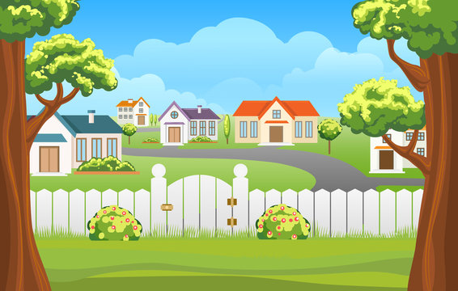

Explore your neighbourhood. List things that are good and things you could make it better.

List 5 things that are good in your neighbourhood
1)
2)
3)
4)
5)

List 3 things to make it better
1)
2)
3)

From your list choose 1 thing to do to make it better in your neighbourhood and choose 1 from the list below to make your neighbourhood better.

- Offer to help water your neighbours garden
- Ask an elderly neighbour if they need help with any chores
- Take out or bring in your neighbours bin
- Write a friendly message for your neighbour
